Science Fair for Key Stage 2

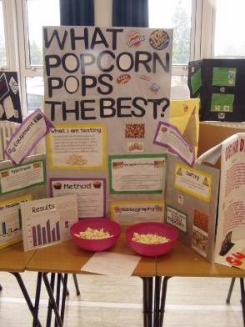
Northfield School for Girls have run a Science Fair for Year 8 for a number of years.
This is an opportunity for pupils to investigate a question of their choosing.
The general principles of Science Fair can be used in Key Stage 2 to support the development of scientific thinking.

How Science Fair works
First of all, this is not a Science Fair as you might imagine from American high school dramas or the Simpsons. Pupils are not building working volcanoes or robots. The idea is to investigate an appropriate question using the skills that are used for science investigations in the classroom (or laboratory).
At the end of the project pupils will have developed either a report or a display board summarising their work!
Why run a Science Fair?
- We have found that Science Fair motivates pupils as they can investigate their own question about the world around them.
- The knowledge and skills required for Science Fair are vital for success in the future, in Science and in other subjects.
- The 2021 Ofsted research review series: Science makes significant mention of the importance of science in Primary school. (https://www.gov.uk/government/publications/research-review-series-science)
- This is also an opportunity to build independent research skills.
- NSG can provide lots of resources to minimise the challenge of preparing for Science Fair and we are available to support further (email m.jackson@nsg.kevibham.org).

The Process

The process is flexible and the total time will be dependent on the level of detail that goes into display work.
The key to managing the project is ensuring that all pupils in the class have a question that can be investigated before moving on to planning.
The detail can be adjusted to suit different pupils and their abilities while still providing challenge for all.
There is also the option of working on one question with a whole class or a particular group if this is more appropriate.
Possible Lesson Outline
- Choosing a project
- Variables and predictions
- Writing a method
- Risk assessment
- Recording results
- Investigations (this might be a homework)
- Drawing graphs
- Conclusions
10+. Completing write-up/display (likely to take several lessons and/or homework)
Health and Safety
If pupils are investigating at home it will be important to involve parents and complete appropriate consents and risk assessments. Some investigations (back-engineering, using flames, using batteries, poisonous plants, pets etc. may not be appropriate at all due to risks).

