10 December 2021

Dear Parent / Guardian

Last Day Arrangements
The last day of term is Friday 17th December. Finish time for all pupils will be 1.25pm, there will not be a lunch break but pupils can collect food from the canteen before they leave if they wish. There will be no after school clubs on this day.

Pupils are permitted to wear their own clothes, which may, of course include a Christmas jumper, on this day. Pupils can bring a voluntary charity donation which will go to the outstanding local community charity, Rubery Swop Shop who provide free uniform, PE kits, shoes and clothes to local families.
Attendance
With all the Covid-related absences of the past years, we are keen for every pupil to attend every day. Normal, content-filled lessons will continue as normal throughout the week, so attendance is essential.
Lost Property Issues
We would appreciate your support in ensuring that your daughter's uniform is fully labelled so if it is lost it is easily returned to her.

Mobile Phones
Please help us remind you daughter that pupils should not be using mobile phones in school time. If they feel ill, a pupil should go to their Head of Year who will call parents / carers if they feel the pupil needs to go home.
Christmas Dinner
All pupils will be able to enjoy a Christmas Dinner on Wednesday 15th December. If your daughter is not in receipt of Free School Meals but your finances have suddenly tightened and you would like your daughter to also be able to enjoy this meal with her friends then we would like to help. Please confidentially call Mrs Bowen on Monday or Tuesday.

In closing, I’d like to thank you for all your support for the school in a hundred different ways this term and to wish you and your families a very happy and restful Christmas.

Yours faithfully

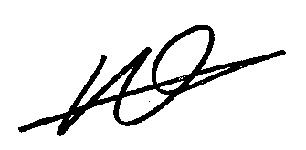

Mr Neil Jones
Headteacher

