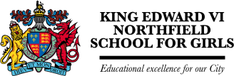
Welcome to year 7 English at Northfield School for Girls!
At King Edward VI Northfield School for Girls, you will study both English language and English literature, looking at many different novels, poems, plays, drama and non-fiction texts. In years 7, 8 and 9, you will also have a weekly Library lesson where you will be encouraged to read lots of books and complete online quizzes to win prizes for excellent reading.
To get ready for your English lessons in year 7 – including some of the topics you will study in your first year - complete the activities below. You could bring in your work to show your English teacher in September!
In year 7, you will start by exploring autobiography writing: this is when a writer writes a version of their life story. You will look at a few famous examples of autobiographies, including Roald Dahl’s Boy and Maya Angelou’s I Know Why the Caged Bird Sings
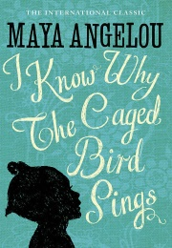
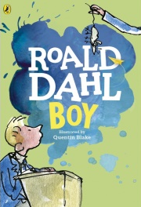
Why not think about how you would write your life story so far below? Use the prompts to plan the chronological story of your life to plan your autobiography. Think about interesting words and language you could use to make your life so far sound interesting and exciting…
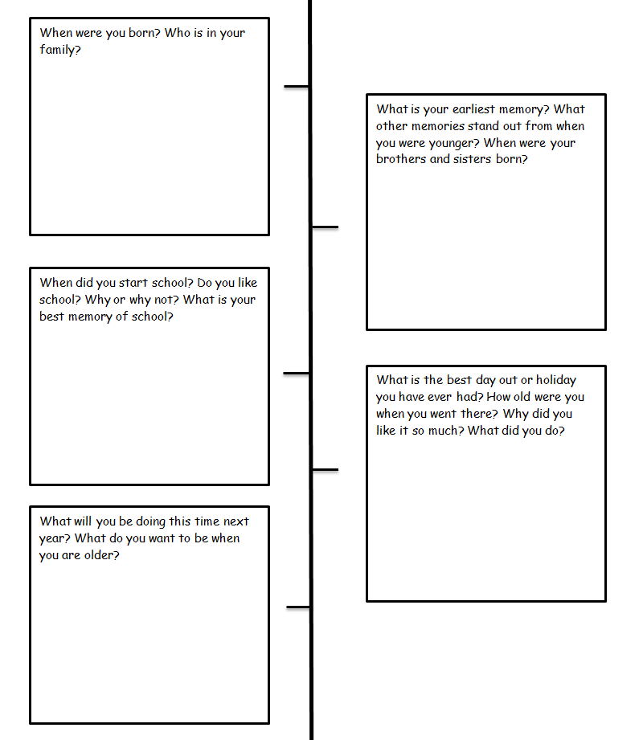
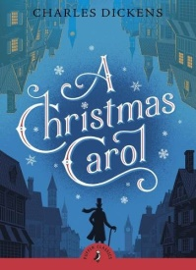
In year 7, one of the books you will read and study is A Christmas Carol by Charles Dickens. You probably already know the story: you may have read it or seen a film or stage version. You will almost certainly know about its main character, Ebenezer Scrooge, a man who seems to hate Christmas and calls it a “humbug”. You may also know that, in the novel, Scrooge is visited by ghosts who convince him to change his ways so by the end, he loves Christmas and becomes a kind man. The first page of the book is printed below – complete the task, looking at how Charles Dickens, the author, ‘hooks’ the reader into the story.

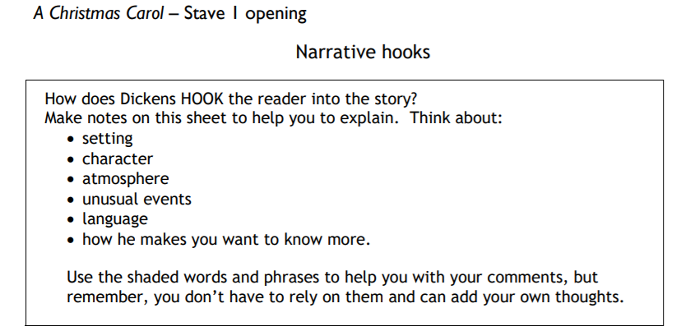
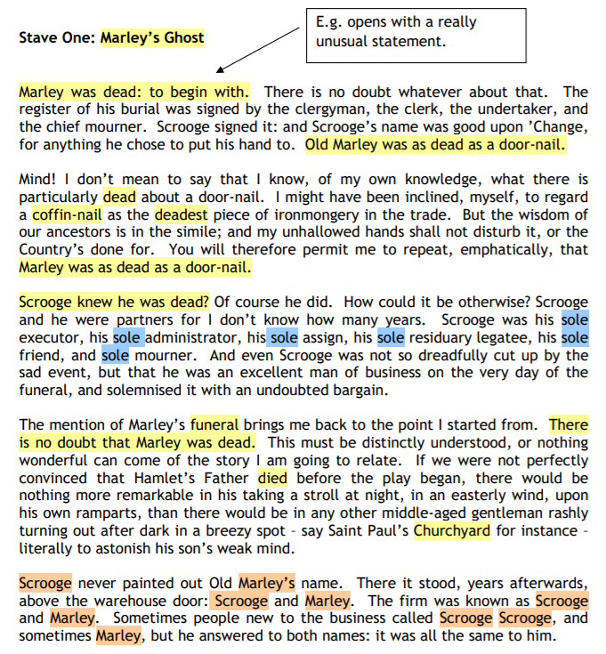
In year 7, you will also study some of the work of probably the most famous writer in the English language, Mr William Shakespeare, a playwright from Stratford-upon-Avon in the midlands. You will learn about his life, times and the theatres that he wrote for in Elizabethan London. In year 7, you will look at a theme that features in several of Shakespeare’s plays… the supernatural. This means you will look at how Shakespeare presents witches, ghosts and even fairies in several of his famous plays.
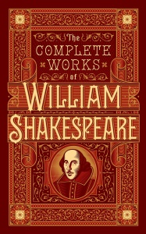
Why not research Shakespeare’s life, works and times by following the prompts below?

