Year 6 Summer Reading List
Reading for pleasure has a huge impact on how well students achieve across the curriculum. Here are some recommendations from our library for an enjoyable summer of reading. Most titles are available free from local libraries and other public libraries across the city. Happy reading!
If you would like personalised recommendations please contact our librarian, Mrs Dunnaker, at:
c.dunnaker@nsg.kevibham.org

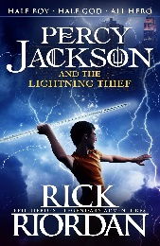
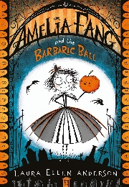
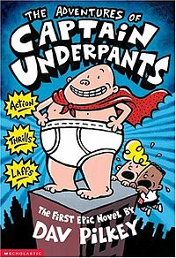
Fun for Everyone
Amelia Fang by Laura Ellen Anderson
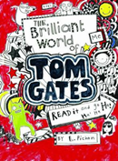
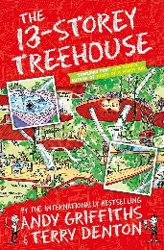
The Adventures of Captain Underpants by Dav Pilkey
Percy Jackson and the Lightning Theif by Rick Riordan
The 13-Storey Treehouse by Andy Griffiths and Terry Denton
The Brilliant World of Tom Gates by Liz Pichon
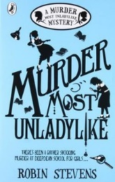
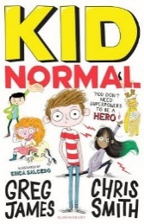
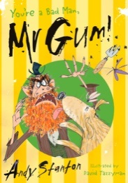
Read Something New
Murder Most Unladylike by Robin Stevens
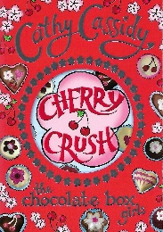
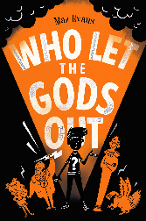
Kid Normal by Greg James
You’re a Bad Man Mr Gum by Andy Stanton
Who Let the Gods Out by Maz Evans
Cherry Crush by Cathy Cassidy
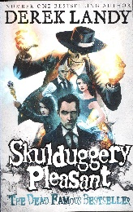
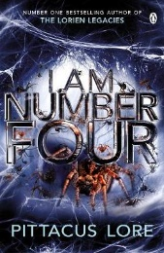
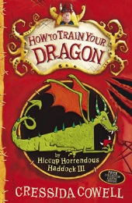
Summer Reading Challenge
I Am Number Four by Pittacus Lore
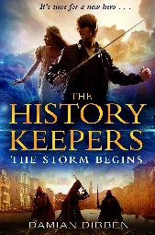
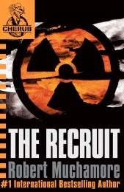
Skuldugery Pleasant by Derek Landy
How to Train Your Dragon by Cressida Cowell
The Recruit by Robert Muchamore
Th History Keepers by Damian Dibben

