*During the Middle Ages, one peasant girl’s faith was about to take her a long way…*

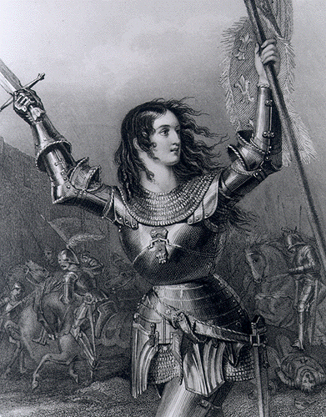

Click on the link and answer these research questions about Joan <https://www.history.com/topics/middle-ages/saint-joan-of-arc>

1. What was Joan’s early life like?

*______________________________________________________________________________________________*

*____________________________________________________________________________________________________________________________________________________________________________________________*

1. *What was her role in the Siege of Orleans?*

*____________________________________________________________________________________________________________________________________________*

*_____________________________________________________________________________________________________________________________________________________________________________________________________________*

*_____________________________________________________________________________________________________________________________________________________________________________________________________________*

*_*

1. *What happened when the English captured her?*

*___________________________________________________*

*____________________________________________________________________________________________________________________________________________________________­­­­­­­­­­­­­­­­­­­­­­________________________________*

*____________________________________________________________________________________________________________________________________________________________*

*Watch the video below and jot down some notes about Joan of Arc*

<https://www.youtube.com/watch?v=Bqcpu1BBBdk>

*____________________________________________________________________________________________________________________________________________________________________________________*

*____________________________________________________________________________________________________________________________________________________________________________________*

*_______________________________________________________________________________________________________________________________________*

*_______________________________________________________________________________________________________________________________________*

This painting was made long after Joan of Arc’s death. Describe how the artist has portrayed her.

_______________________________________________________________________________________________________________________________________________________________________________________________________________________________________________________

*KEY INFORMATION: Joan of Arc was born in _______ and died in ________. She was born as a _____________(job title) but her belief in God lead to convincing the King VII that she should lead the French army to victory over the ____________(enemy) in the ___________(name of war).*

Useful websites, videos and podcasts

<http://www.bbc.co.uk/history/historic_figures/de_medici_catherine.shtml>

<https://www.britannica.com/biography/Catherine-de-Medici>

Joan of Arc "The Maid of Orléans" became a heroine of France for her role the Hundred Years' War with England.

meanwhile, she…