*During the Industrial Revolution some in America were still fighting slavery..*

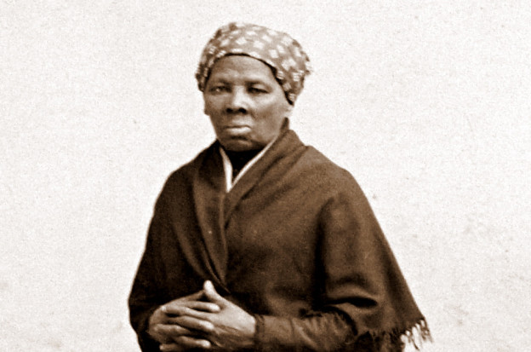

meanwhile, she…

What does this wanted poster tell you about Harriet Tubman?

_____________________________________________________________________________________________________________________

______________________________________________________________________________

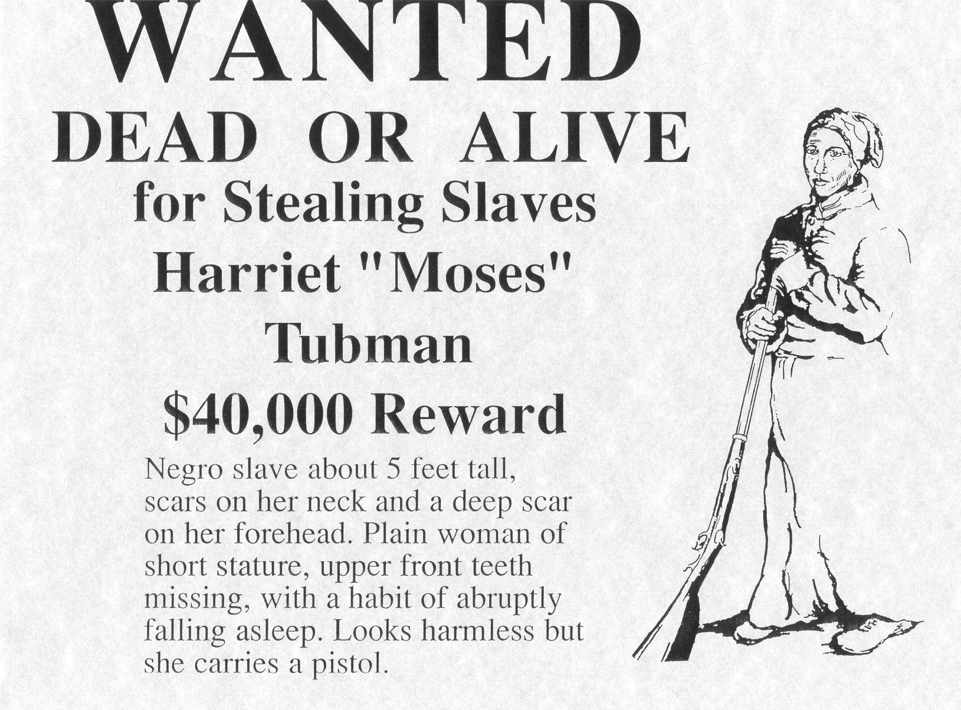

In 2019 a film was made about Harriet. Watch the trailer and tell me what it tells you about her. <https://www.youtube.com/watch?v=GqoEs4cG6Uw>

______________________________________________________________________________________________________________________________________________________________________________________________________________________________________________________________________________________________________________________________________________________________

Click on the link below to find out more about Harriet and answer the questions below:<https://www.history.com/topics/black-history/harriet-tubman>

1. *When was she born and when did she die?*

*____________________________________________________*

1. *How did she escape from slavery?*

*________________________________________________________________________________________________________________________________________________________________________________________________________________*

1. *What was the underground railroad and what was her role in it?*

*________________________________________________________________________________________________________________________________________________________________________________________________________________*

1. *What was the fugitive slave act?*

*____________________________________________________________________________________________________________________________________________________________________________________________________________________________*

*.*

Watch this video and write down notes below about Harriet <https://www.youtube.com/watch?v=rHc5XcB1fmA>

________________________________________________________________________________________________________________________________________________________________________________________________________________________________________________________________________________________________________________________________________________________________________

Useful websites, videos and podcasts

<https://www.history.com/topics/black-history/harriet-tubman>

<https://www.britannica.com/biography/Harriet-Tubman>

*Harriet Tubman was saving lives!*

*KEY INFORMATION:* Harriet Tubman was an escaped _____________ who became a “conductor” on the ____________________, leading slaves to freedom before the Civil War, all while carrying a bounty on her head. But she was also a nurse, a Union spy and a ________________ supporter. Tubman is one of the most recognized icons in American history and her legacy has inspired countless people from every race and background.