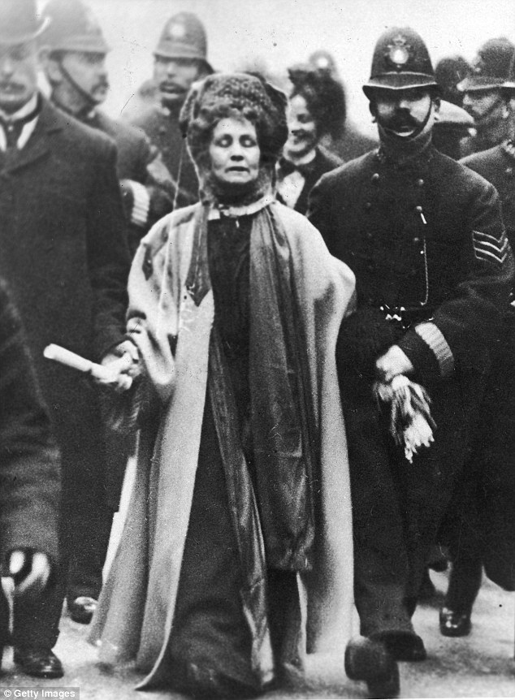

*Before the First World War there was some controversial characters in the British Empire.*

meanwhile, she…

Useful websites, videos and podcasts

<https://www.britannica.com/biography/Emmeline-Pankhurst>

<https://www.bbc.co.uk/bitesize/topics/zd8fv9q/articles/zh7kdxs>

<https://www.youtube.com/watch?v=98xcEcYpE9w>

This became the slogan for Pankhurst’s Suffragette’s movement. What do you think it means?

­­­­­­­­________________________________________________________________________________________________

________________________________

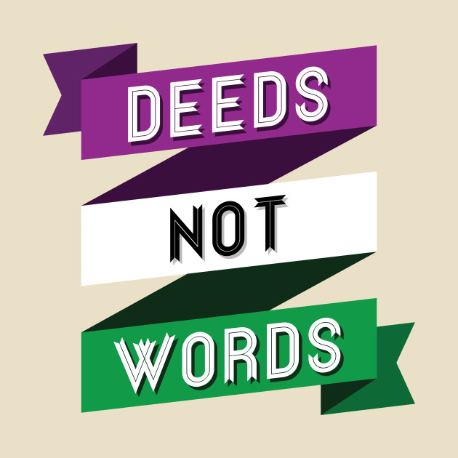

Watch the video and jot down some notes below

<https://www.youtube.com/watch?v=Pup3v3qdrPA>

*____________________________________________________________________________________________________________________________________________________________________*

*____________________________________________________________________________________________________________________________________________________________________*

*_______________________________________________________________________________________________________________________________________________________________________________________________________________________________________________________________________________________________*

In November 1913 Pankhurst travelled to America to make a speech about Universal Suffrage. Watch the video and summarise the meaning of the speech. <https://www.youtube.com/watch?v=NL5s9dk9U4w>

__________________________________________________________________________________________________________________________________________

*____________________________________________________________________________________________________________________________________________________________*

Click on the link and answer these research questions about Pankhurst.<https://www.biography.com/activist/emmeline-pankhurst>

1. *What was the WSPU and how did they protest?*

*____________________________________________________*

*____________________________________________________*

1. *What was the Cat and Mouse Act?*

*____________________________________________________*

*___________________________________________________________________________________________________________________________________________________________*

*_____________________________________________________*

1. *Did her actions change during the First World War?*

*____________________________________________________________________________________________________________________________________________________________*

*________________________________________________________________________________________________________*

*________________________________________________________________________________________________________*

*Emmeline Pankhurst believed that deeds had a greater impact in the fight for universal suffrage.*

*KEY INFORMATION:* Emmeline Pankhurst was born in ______(date) in ______________. She was a leading British women's rights activist, who led the movement to win the right for women to vote. Whereas Millicent Fawcett led the Suffragist movement Pankhurst led the______________.