*During the Industrial Revolution there were some revolutionary figures..*



meanwhile, she…

Ada’s parents prioritised teaching her science and maths how might that have had an impact on her life?

______________________________________________________________________________________________________________________________________________________________________________________________________________________________________________________________________________________________________________________________________________________________

Click on the link below to find out more about Ada Lovelace and answer the questions below:

<https://www.biography.com/scholar/ada-lovelace>

1. *What is Ada Lovelace famous for?*

*____________________________________________________________________________________________________________________________________________________________________________________________*

1. *When was she born and when did she die?*

*______________________-*

1. *Who were Ada’s famous parents?*

*____________________________________________________________________________________________________________________________________________________________________________________________*

1. *What was the Analytical Engine?*

*____________________________________________________________________________________________________________________________________________________________________________________________________________________________*

*.*

Watch this video and write down notes below about Lovelace <https://www.youtube.com/watch?v=uBbVbqRvqTM>

________________________________________________________________________________________________________________________________________________________________________________________________________________________________________________________________________________________________________________________________________________________________________

Useful websites, videos and podcasts

<https://www.bbc.co.uk/newsround/49960544>

<https://www.britannica.com/biography/Ada-Lovelace>

*Ada Lovelace was working on some serious Maths!*

What does the author of this book suggest about the significance of Ada Lovelace?

_____________________________________________________________________________________________________________________

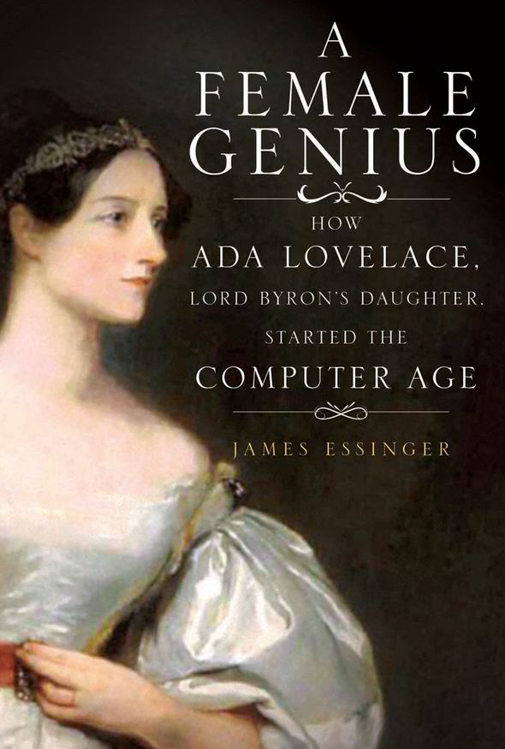

*KEY INFORMATION:* In 1833, Ada Lovelace began working with and learning from­­­__________________ She became fascinated with his **Difference Engine** machine and used her relationship with her tutor, Mary Somerville, to visit Babbage as often as she could. Babbage was impressed by Lovelace's intellect and analytic skills. In 1842-1843 she began working with Babbage’s _______________________ machine.