March 2021

Dear Parents

Year 9 Future’s Evening, Thursday, 25th March 4pm – 7pm - An Online Teams Event

For pupils in Year 9 we have combined Parents’ Evening and Options’ Evening into one event – Future’s Evening.

This is an exciting time for Year 9 pupils and yourselves, where you consider different subject choices studied for the next two years.

We are inviting you to this event in order to discuss your child’s progress with their teachers in English, Mathematics and Science. It will also provide an opportunity to discuss other GCSE and other KS4 courses with the appropriate teacher.

A booklet has been provided to assist you in making these choices. I hope you will find the guide useful in helping you make the all-important decisions that your child faces in the coming weeks.

Although the current situation prevents us from holding this evening in person, we are offering you the opportunity to discuss your child’s progress and options with their teacher via an online video call on Thursday 25th March, 4pm to 7pm.

You can book your appointments using the new online appointment booking system. This allows you to choose your own appointment time with the teachers and you will receive an email confirming your video appointment. Information on how to log on to the online Parents’ Evening system will be forwarded in another letter.

At this stage it is important to bring to your attention the English Baccalaureate. It is a recognised measure of success across a suite of subjects – specifically English, Mathematics, History or Geography, the Sciences (including Computer Science) and a Language. These are subjects most likely to be required or preferred for entry to degree courses at universities and the ones classed as ‘gateway’ subjects as they keep most doors open for different future directions.

Taking this into account and recognising the aspirations and ambitions of many of our pupils to go onto higher education courses, we will be directing some pupils to take GCSE French as one of their four option choices. However, we realise that in a few cases this might conflict with already identified career paths. If you find this to be case, please contact Mr Conlon and he will arrange a meeting where a solution can be found. Equally, those pupils not specifically directed to take GCSE French are able to do so as one of their option choices.

It is important that we provide time to make decisions after the Futures Evening so, we ask that completed options forms are placed in a collection box that will be situated outside Reception by Monday 29th March 2021.

Once your child has made their subject choices and submitted their form they may have a short meeting with a senior member of staff at a later date, to discuss these further.

We look forward to your participation on the evening of Thursday 25th March.

Yours sincerely
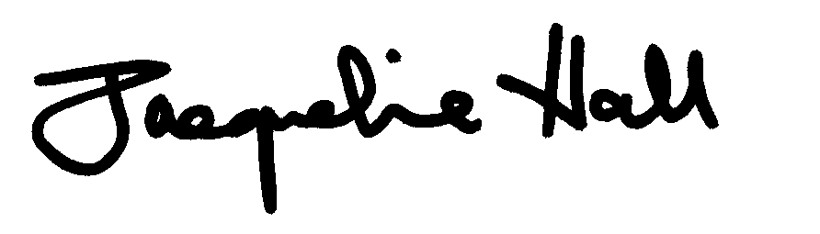

J Hall
Acting Headteacher

