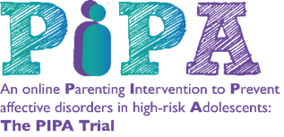

Dear Parent/Carer
The PIPA Trial
We are writing to you about The PIPA Trial which is being conducted by the University of Warwick. King Edward VI Northfield School for Girls are collaborating with the research team on this trial which is exploring the effectiveness of an online resource for parents/carers to help reduce depression and anxiety in young people.

Families of young people aged 11-15 years at King Edward VI Northfield School for Girls are being invited to take part (please note that your name and address details have not been shared with the trial team). Attached is an information sheet which will give you more details of the trial and what your participation would involve. We have also attached an information sheet for your child.

If you have any questions about the trial and would like to find out more information, please contact the PIPA trial team using the contact details below. Mrs Reeves is the ‘PIPA champion’ for King Edward VI Northfield School for Girls and you can also speak to her about the trial.

If you are interested in taking part in the trial, please visit https://ctu.warwick.ac.uk/PIPAmobile/parent-consent to register. You will then need to enter this code 36497810 to access the database and to provide consent for you and your child to take part.

Many thanks for taking the time to read this email and we look forward to hearing from you.

Mrs E Reeves and The PIPA Trial Team

PIPA Trial Team – University of Warwick
Email: PIPA@warwick.ac.uk
Phone: 02476574316 or 02476575078
Website: www.warwick.ac.uk/pipa

